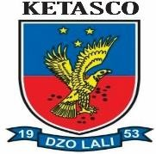KETA SENIOR HIGH TECHNICAL SCHOOL PROSPECTUS

OUR VISION

Developing professional graduates in droves for the socio-economics development of humankind

MISSION

To enhance students’ ability to enter tertiary institutions by identifying students’ unmet needs and to offer excellent educational services that address their needs by so doing give society value for money.

CORE VALUES

These are sets of concepts that are important for the school they articulate the belief system that provides the basic values purpose and direction for the school. These values are fundamental to staff and students. This is a way of obtaining commitment to a grand purpose. The school’s core values are clined from the acronym “Ketasco”

K – Know-How E – Excellence T – Tenacity
A – Accountability
S – Service to Society C – Competence
O - Obligation

KIT LIST FOR BOYS
DAY STUDENTS

- Four (4) passport sized photographs. (To be taken in the second semester)
- NHIS Card (Active)
- A pair of brown or black leather sandals
- A pair of Khaki Trousers (Brown)
- A pair of shorts (Khaki)
- Canvas for sports (white)
- Black leather belt (ordinary hook and buckle without designs)
- A pair of Black or Brown leather shoes (low heel) to be worn on Sundays for church services and not
for school.
- Water Bottle one (1) litre size
- A pair of long sleeve white shirt
- A pair of white short sleeves shirt
- A pair of red and white check shirt with one breast pocket on the left.
- One male Jumper white short-sleeve
- White plain “T” shirt (not Polo) for P.E.
- Loose black nylon shorts (with white stripes at the sides)
- Umbrella or rain coat
- Torch light and dry cell
- Two (2) Kilt (hose) socks
- One (1) box of white board marker (not permanent)
1

KIT LIST FOR BOYS BOARDING STUDENTS
- Four (4) passport sized photographs. (To be taken in the second semester)
- NHIS Card (Active)
- Two cups and a pair of plates (not ceramic or glass)
- Cutlery set
- 2 Napkins and a lunch bag for plates
- A pair of brown or black leather sandals
- A pair of Khaki Trousers (Brown)
- A pair of shorts (Khaki)
- Canvas or camp boot (camboo) for sports (no other colour but white)
- An Umbrella or Raincoat
- A pair of white socks
- Black leather belt (ordinary hook and buckle without designs)
- A pair of Black or Brown leather shoes (low heel) to be worn on Sundays for church services and
not for school.
- An electric pressing iron (3pins to plug)
- Water Bottle one [1] litre size
- Student mattress covered with mackintosh leather
- A pair of plain white cotton pillow cases
- Blanket
- Two buckets (metal and plastic)
- Toiletries
- Torchlight and dry cell batteries
- A pair of Pyjamas
- Six (6) or more Singlets and underwear
- Six (6) or more boxer-short
- Six (6) or more handkerchiefs.
- A pair of Bathroom slippers.
- A pair of long sleeve white shirt.
- A pair of white short sleeves shirt.
- A pair of red and white check shirt with one breast pocket on the left.
- A medium size Chop-box and Trunk or medium size Valix bag.
- One male Jumper white short-sleeve
- White plain “T: shirt (not Polo for P.E.)
- Loose Black nylon shorts (with white stripes at the sides) The type preferred by police recruits.
- Two (2) kilt (hose) socks.
- D-lion bed-bug control (ready to use 250 ml)
- One (1) box of white board marker (not permanent)

KIT LIST FOR GIRLS
DAY STUDENTS
  - Four (4) passport sized photographs (To be taken in the second semester)
  - NHIS Card (Active)
  - A pair of brown or black leather sandals
  - Canvas for sports (white)
  - A pair of white socks
  - A pair of Black or Brown leather shoes (low heel) for Sunday church service and not to be worn to school.
  - A set of “cooper” earrings (small size)
  - White flock with sleeves for church (prescribed by the school)

2

  - A pair of red and white check (small eyes) dress.
  - White plain “T: shirt (not Polo for P.E.)
  - Loose Black nylon shorts (with white stripes at the sides) The type preferred by police recruits.
  - Torchlight and dry cell batteries
  - Two (2) kilt (hose) socks
  - Water Bottle one [1] litre size
  - Umbrella or rain coat
  - One (1) box of white board marker (not permanent)

KIT LIST FOR GIRLS BOARDING STUDENTS
- Four (4) passport sized photographs. (To be taken in the second semester)
- NHIS Card (Active)
- Two cups and a pair of plates (not ceramic or glass)
- Cutlery set
- 2 Napkins and a lunch bag for plates
- A pair of brown or black leather sandals (e.g. east – wes)t for class
- Canvas or camp boot (camboo) for sports (no other colour but white)
- An Umbrella or Raincoat
- A pair of white socks
- Black leather belt (ordinary hook and buckle without designs)
- A pair of Black or Brown leather shoes (low heel) to be worn on Sundays for church services and
not for school.
- An electric pressing iron (3pins to plug)
- Water Bottle (one [1] litre size)
- Student mattress covered with mackintosh leather
- A pair of plain white cotton bed sheets
- A pair of plain white cotton cases
- Pillow covered with leather mackintosh.
- Blanket
- Two buckets (metal and plastic)
- Toiletries
- Torchlight and dry cell batteries
- Two non-transparent Night Gowns.
- Six (6) panties and 4 or more Brassiers.
- Six (6) or more boxer-short
- Six (6) or more handkerchiefs.
- A set of “cooper” earrings (small size).
- A pair of Bathroom slippers.
- White frock with sleeves for church (prescribed by the school) pg 24)
- Sanitary pad for Girls (at least 4).
- A pair of white vest.
- Six (6) or more underwear knickers.
- Two (2) black underskirt.
- A pair of red and white check (small eyes) dress.
- Red and white check sewn into long sleeves and trousers (to be worn only for preps)
- A medium size Chop-box and Trunk or medium size Valix bag.
- White plain “T: shirt (not Polo for P.E.)
- Loose Black loose nylon shorts (with white stripes at the sides) The type preferred by police recruits.
- Two (2) kilt (hose) socks.
- D-lion bed-bug control (ready to use 250 ml)
- One (1) box of white board marker (one permanent)
3

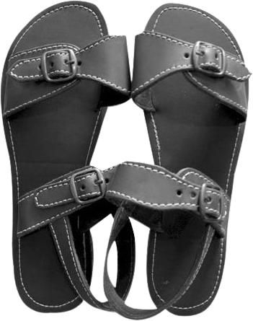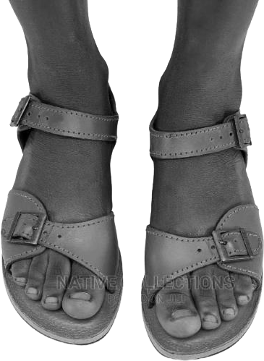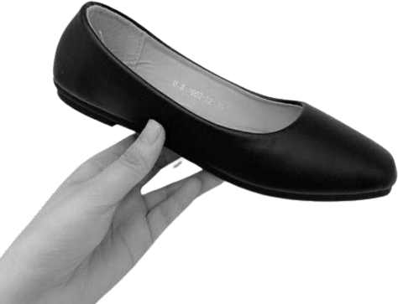ITEMS TO BE COLLECTED FROM THE STUDENT BY THE SCHOOL.
  - Plastic sweeping brush
  - Bleach 1 liter (parazone, powerzone etc) 2
  - Washing Powder 2kg (e.g. So-klin, Omo, Yazz or Doffi) 1
  - Mop plus Bucket one (1) each (boys and girls) 1 each
  - Standing Broom 2
  - Toilet Roll 1 pack
  - Dish cloth duster (not marker board duster but rather the one used to wipe cars) 2 each.
  - D-lion bed-bug control (ready to use 250 ml)
  - One (1) box of White board marker (to be submitted at the Assistant Headmaster Academic’s office)

ITEMS NEEDED BY VISUAL ARTS STUDENTS
- Poster Colour and Brushes
- Sketch Book (3) (42cm x 30cm or more)
- Pack of Drawing pencils (2B-8B or 12B)
- Overall coat (blue – black Khaki)

ITEMS NEEDED BY TECHNICAL STUDENTS

- Safety Boot
- Overall/Overcoat (Blue-Black Khaki)
- Drawing sheet (A3)

ITEMS NEEDED BY AGRIC STUDENTS
- Wellington boots
- Rubber gloves
- Garden fork

SAMPLE OF FOOTWEAR PRESCRIBED

4

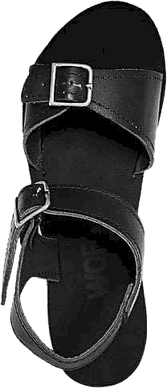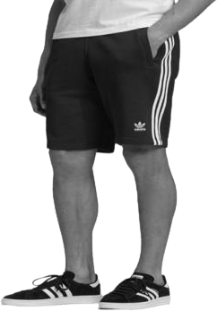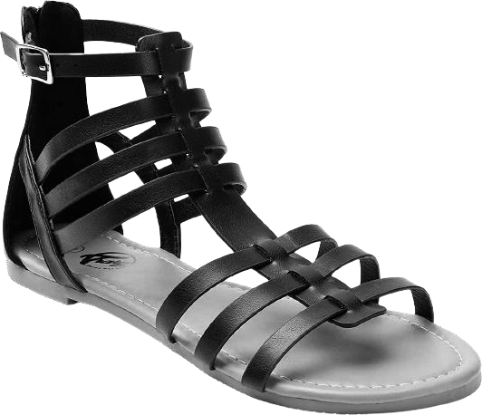

UNPRESCRIBED

Girl’s attire for preps

5

