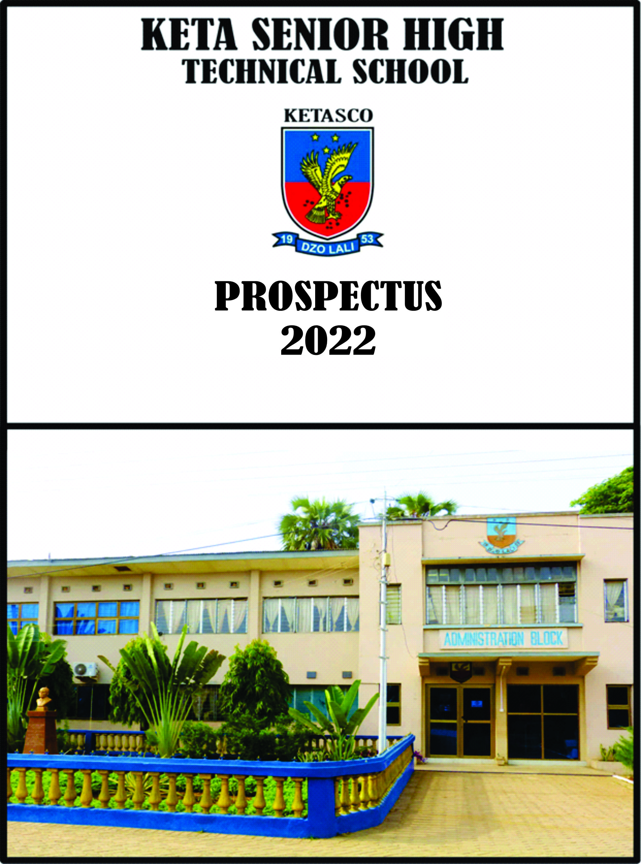

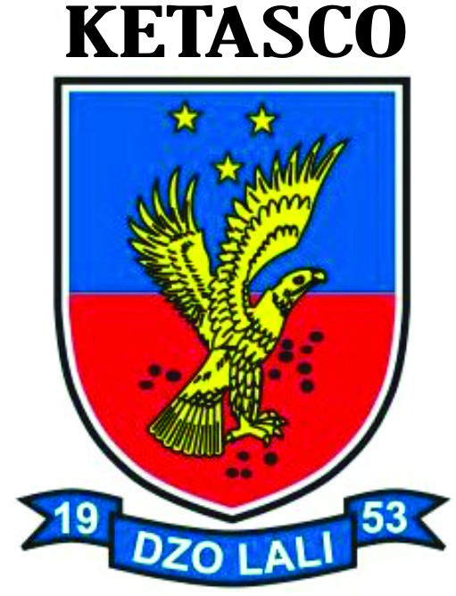
KETA SENIOR HIGH TECHNICAL SCHOOL
PROSPECTUS

OUR VISION
We aspire to remould our school into one of the first ten educational centres nationwide, typically recognized for their moral rearmament, excellent academic pedigree, and a first class sporting institution, milling out men and women for our motherland and the world.
OUR MISSION
We are charged to build our students into decent, mature and dignified people, proud of their heritage, empower our tutors and workers, and collaborate with all decent partners in and outside the educational industry, so our school becomes the first choice for all discerning and determined parents.
THE SCHOOL ANTHEM
- Once to every man and nation comes the moment to decide.
In the strife of truth with falsehood
For the good or evil side
Some great cause, God's new Messiah
Offering each the bloom or blight and the choice goes by forever;
'Twixt that darkness and that light.
- Then to side with truth is noble
When we share her wretched crust
Ere her cause bring fame and profit,
And 'tis prosperous to be just;
While the coward stands aside,
Till the multitude make virtue,
Of the faith they had denied.
- By the light of burning martyrs,
Christ, thy bleeding feet we track,
Toiling new calvaries ever
With the cross that turns not back,
New occasions teach new duties;
Time makes ancient goods uncouth
They must upward still and onward
Who would keep abreast of truth.

- Though the cause of evil prosper,
Yet 'tis trush alone is strong;
Though her portion be scaffold,
And upon the throne be wrong,
Yet that scaffold sways the future,
And, behind the dim unknown,
Standeth God within the shadow,
Keeping watch above His own.

ROLE OF HONOUR
(Headmasters of KETASCO)
- Mr. Nathan Quao (1953-1956)
- Mr. J.W Abruquah (1957-1963)
- Mr. R.E.K. Matanawui (1963-1970)
- Mr. F.Y. Amuzu (1970-1983)
- Mr. J.A.K. Kaleku (1984-1988)
- Mr. J.Y. Deku (1990-2005)
- Mr. O.K. Gbagbo (2005-2008)
- Mr. D.K. Sedanu-Kwawu (2008-2017)
- Mr. F.C.K. Agbakey (2017-2019)
- Mr. I.K. Dzidzienyo (2019 to date)
ACTING
- Mr. C.K. Mensah (1983-1984)
- Mr. C.K. Mensah (1988-1990)

BOARD OF GOVERNORS OF THE SCHOOL
Keta Senior High Technical School (KETASCO) has a 13 member Board of Governors. The composition is specified by the Ghana Education Service (G.E.S.). The School Board exercises supervisory role over management activities of the school. It meets regularly to appraise the activities going on in the school.
In the area of discipline, the Board is the final authority to approve punishments that the school may deem fit for a particular offence. The Board is the highest decision making body of the school.

WELCOME TO KETASCO
It is heartwarming to welcome you to Keta Senior High Technical School (KETASCO), a citadel of academic excellence. On behalf of the Board of Governors, management, The Parent Teacher Association (PTA), Old Students Association, Staff and students of Keta Senior High Technical School, we welcome all parents to the school and their wards who have gained admission this academic year. Several opportunities abound in KETASCO.
The school offers programmes such as General Science, General Arts, Business, Home Economics, Agricultural Science, Visual Arts and Technical.
Since the school was established, it has recorded 100% passes in the Ordinary and Advanced Level Examinations. The same can be said of Senior High School graduates who continue to improve upon previous academic records propelling the school to be enrolled into the exclusive club of the best 100 schools in Ghana.
Currently, KETASCO is making a huge stride as one of the best Senior High Schools in the Volta Region Ghana. This is reflected in her exploits in the National Science and Maths Quiz competition where the school had qualified for the Semi Finals for three consecutive years from 2017-2020. KETASCO is the bronze medalist in the 2021 edition of National Science and Maths Quiz (NSMQ).
The West African Examination Council (has as from last year November, 2020) chosen the school as a center for the conduct of the November-December Examinations. KETASCO has become a force to reckon with as students who qualify to tertiary institutions continue to soar.
Facilities in KETASCO cannot be glossed over. The school has an ultra-modern state of the art library, computer laboratory, multipurpose sports complex, fishponds, artefacts, vegetable farms, coconut and mango plantation and woodlots coupled with beautiful lagoon and sea views. Any visitor to the school is met with a green fauna and flora which whets one's appetite to be part of such an environment.
Remember you have made the right choice by enrolling in KETASCO. Feel at home, undertake your studies seriously not forgetting the purpose for which you came to the school. You are warmly welcome.
HISTORY OF KETASCO
Keta Senior High Technical School (KETASCO) was officially founded on the 27 February, 1953 in a rented premises; Kudzawu's house, opposite the Dzelukope branch of Electricity Company of Ghana. It was a day school at commencement. The school was to provide quality secondary education to the entire catchment area. Eight (8) subjects were taught then. These included English Language, Mathematics, Science and Geography. Mr. Nathan Quao was appointed as the first Headmaster assisted by Mr. Sosthenes Sorkpor.
These two gentlemen shared all the eight (8) subjects offered between them and taught the students who excelled.
The pioneer students were twenty-five (25). This was made up of seventeen (17) boys and eight (8) girls.
On attainment of Ghana's Republican status on 1 ^{st} July,1960, Keta Senior Secondary School became a beneficiary of Dr. Kwame Nkrumah's Trust Fund Schools that were built all over the country. This was what moved the school to its new permanently acquired land. On the 4th of November 1960, Mr. Kwasi Agbeli Gbedema, the then Minister of Finance cut the sod for work to start on the first block at this permanent site. At the time of this sod cutting, Mr. J.W. Abruquah took over the headship of the school. Among others who witnessed the sod cutting ceremony were the then Volta Regional Commissioner and a Board member, Mr. C.H. Chapman.
The Board Chairman, Rev. F.K. Fiawoo facilitated the building of the school by Ghana Education Trust. Weeks after the sod cutting ceremony by Mr. Gbedema, Dr. Kwame Nkrumah, the President of the Republic visited the school’s new site and among other activities, planted the Indian almond tree which still stands as a historic monument, providing nostalgic memories and good shade for staff, students and visitors.
On 11 September, 1961, just one year after the sod cutting ceremony, Forms Two and Four students moved to the new block. All the school had at the time was one classroom block, the administration block, assembly hall and a science laboratory together with the dining hall. The partially completed dining hall was temporarily used as a hostel for students coming from far off communities.
In 1967, with the admission of the first batch of “A Level students, Rev. R.E.K. Matanawui, the third Headmaster's idea of a permanent hostel for the school came into fruition. A full boarding facility was subsequently introduced. The pioneer 'A' Level students were eight (8) boys and three (3) girls.
KETASCO's growth had been steady and progressive ever since.
A school that commenced with a mere twenty five (25) students in the 50s is now having a student population of three thousand five hundred and sixty two (3,562) offering seven programmes. KETASCO has always been among the first class second cycle schools in Ghana providing world class education to young men and women.

REPORTING PROCEDURE
A. GUIDELINES FOR NEW ARRIVALS
I. Students are to undergo physical examination to ensure that they are in the prescribed attire, hair trimmed according to school regulation etc. at the school gate.
- Students especially boarders are to report to the Senior Housemaster and Senior Housemistress or their assistants for their Kit-list to be inspected.
- Each student would be allocated to a house of residence after going through a registration process. Day students are obliged to undergo the registration process to be affiliated to a house.
- Students are advised to keep their registration receipts which will be used for collection of items from the school’s store.
- Boarders are obliged to report to their houseparents’ for registration and dormitory allocation.
- Boarders are to report to the Senior Housemaster and Senior Housemistress for allocation of tables at the dining hall.
- Under no circumstance should a student give pocket money or any personal items to a senior for safe keeping. Such monies should be kept with their houseparents.

B. GUIDELINES FOR SUBSEQUENT ARRIVALS
i. Students are to report to their House-parents for registration immediately on arrival.
ii. Boarders are to report to the Senior Housemaster and Senior Housemistress for dining hall table allocation.
DISCIPLINARY ISSUES
The school adheres strictly to the Ghana Education Service Disciplinary Code and in addition has its own rules and regulations to suit the local conditions. Refer to the rules and regulations in subsequent pages.
VISITING HOURS
- All visitors are received by students between the hours of 3pm and 5pm on Saturdays and Sundays once every month.
- Visitors are not supposed to be taken to the dormitories. (This includes day students)
- All visitors must leave the compound by 5pm. Should it become necessary to visit a student outside the visiting hours, permission must be sought from the school administration.
SCHOOL GATHERING
All school gatherings are compulsory for students.
They include General Assembly, Attendance to class and Dining hall, Grounds work, Religious meetings, club and societal meetings, and emergency assembly as well as all cocurricular activities.
TIME SCHEDULE
Weekly time schedule activities
1. Rising bell
a. Sunday to Saturday: 5:00am
2. Morning duties and dressing up
- Monday to Friday:5:00am-6:15am
- Saturday: 5:00am-9:30am
- Sunday:5:am-9:30am

3. Silence hour
a. Monday - Friday: 7:00am-7:30am
4. Meal time
a.Breakfast:7:30am-8:00am
b.Lunch:12:00pm-12:30pm
c.Supper:5:00pm-5:30pm
The siren/drum will sound when it is time for meal.
- Students must be seated five minutes after the siren/drum sounds
CLASS HOURS
- Class hours are as follows:
8:00am to 12 noon and 12:30 pm to 3:30pm.
- Siesta time
Siesta is observed from: 3:300pm-4:00pm.

PREPS TIME
Monday to Friday: 6:00pm-9:00pm
Saturdays: 10am-12noon
Sunday, church (services/private studies):6:00pm-9:00pm.
ACADEMIC PROGRAMMES
Keta Senior High Technical School (KETASCO) is a second cycle institution that offers various courses leading to the award of the West African Senior Secondary Certificate (WASSCE). At the General Science, Business, Home Economics and Technical. In 1995, the General Arts programme was introduced with some selected options. In 1997 more options were introduced giving the General Arts Students more programmes to select from.
In 2006, General Agric was introduced under the headship of Mr. D.O. Gbagbo the 7th Headmaster of the School. The first batch of these students wrote the WASSCE in 2009 and scored 100%.
When Mr.D.O. Gbagbo, the 7th substantive headmaster took over the helm of affairs, the students had the option to select either Animal Husbandry or Crop Husbandry and Horticulture as one of their elective subjects. The pioneer students under this programme also scored 100%. Since then, the results have been extremely excellent.

SELECTION OF SUBJECTS
All SHS 1 students offer the following compulsory core subjects:
- English Language
- Mathematics
- Integrated Science
- Social Studies
These are offered in addition to four other elective subjects selected from one’s programme of study.
COURSES OF STUDY FOR GENERAL ARTS
GROUP1
- Economics
- Geography
- French
- Elective Mathematics

GROUP 2
- Economics
- Geography
- Government
- Elective Mathematics
GROUP 3
- Economics
- Geography
- Government
- Christian Religious studies (CRS)

GROUP 4
- Economics
- History
- Literature-In-English
- Christian Religious studies (CRS)
GROUP 5
- Ewe
- Literature-In-English
- Christian Religious studies (CRS)
- French
GROUP 6
- Christian Religious studies (CRS)Ewe
- Ewe
- Literature-In-English
- Government
GROUP 7
- Economics
- Ewe
- History
- Literature-In-English
AGRICULTURE SCIENCE
- Animal Husbandry/ Crop Husbandry and Horticulture
- Chemistry (Compulsory)
- Physics/ Elective Mathematics
- General Agriculture

VISUAL ARTS
- General Knowledge in Art (Compulsory)
- Graphic Design/Picture Making/Textiles
- Biology/Elective Mathematics/French/Music
- Ceramics/ Leatherwork

TECHNICAL PROGRAMME
- Technical Drawing
- Elective Mathematics
- Electronic/Building Construction/chemistry
- Woodwork /physics

GENERAL SCIENCE
GROUP1
- Elective Mathematics
- Physics
- Chemistry
- Biology
GROUP 2
- Elective Mathematics
- Physics
- Chemistry
- Geography
GROUP 3
- Elective Mathematics
- Physics
- Chemistry
- Information and Communication Technology
GROUP 4
- Elective Mathematics
- Physics
- Chemistry
- Technical Drawing

Group 5
- Elective Mathematics
- Physics
- Chemistry
- French

BUSINESS PROGRAMME

GROUP1

- Business Management
- Financial Accounting
- Business Mathematics and Principle of Cost Accounting
- Economics/ French / Music

GROUP 2
- Business Management
- Financial Accounting
- Economics/ French /Music
- Elective Mathematics

HOME ECONOMICS
- Management in living
- General Knowledge in Art/ Economics/ French/Textile
- Food and Nutrition/Clothing and Textiles
- Biology/ Elective Mathematics/Chemistry

GUIDANCE AND COUNSELLING SERVICES
The school has a Guidance and Counselling Unit which provides required service to staff and students.
HEALTH SERVICE
The health of an individual is paramount in daily life. As such, the school operates a health facility (clinic) that deals with minor cases. Cases that are beyond the nurses are referred to the Municipal Hospital. It is therefore mandatory that parents ensure proper registration of their wards under the National Health Insurance Scheme. The Governing Board of the school makes it a pre-requisite for admission.

MEANING OF KETASCO MOTTO AND EMBLEM
The school’s motto Dzo Lali (Now or Never) and the Emblem; the eagle was subject of intense debate by the pioneer staff members of the school. It implores us to do everything right now for there may never be a time as the eagles soar high in the sky, the emblem entreats all to work hard.
The sky should be the limit to their work, studies and enterprise.

KETA SENIOR HIGH TECHNICAL SCHOOL KIT LIST
KIT LIST FOR BOYS DAY STUDENTS-2022
Boys kit-list Day Students
- NHIS Card (Active)
- Two cups and a pair of plates (not ceramic or glass)
- Cutlery set
- 2 Napkins and a Lunch bag for plates
- A pair of brown or black leather sandals
- A pair of Khaki Trousers (Brown)
- A pair of shorts (Khaki)
- Canvas for sports (white)
- An Umbrella or Raincoat
- A pair of white socks
- Black leather belt (ordinary hook and buckle without designs)
- A pair of Black or Brown leather shoes (low heel)
- An electric pressing iron (3pin plug)
- Water Bottle (one [1] litre size)
- House Jerseys according to House colours for Boys and (Without any writing or embossment) of a football club etc. It must be plain.
- House 1. Green
- House 2. Blue
- House 3. Yellow
- House 4. Red
- House 5. White
- Torchlight and dry cell batteries
- A pair of Pyjamas
- Six (6) or more Singlets and underwear
- Six (6) or more boxer-short
- Six (6) or more handkerchiefs
- A pair of Bathroom slippers
- A pair of long sleeve white shirt
- A pair of white short sleeves shirt
- A pair of blue and white check shirt with one breast pocket on the left.
- One male Jumper white short-sleeve.

KIT LIST FOR GIRLS DAY STUDENTS-2022
Girls’ kit-list Day Students
- NHIS Card (Active)
- Two cups and a pair of plates (not ceramic or glass)
- Cutlery set
- 2 Napkins and a lunch bag for plates.
- A pair of brown or black leather sandals (eg east- west)
- Canvas for sports (white)
- An Umbrella or Raincoat
- A pair of white socks
- A pair of Black or Brown leather shoes (low heel)
- An electric pressing iron (3pin plug)
- Water Bottle (one [1] litre size)
- House Jerseys according to House colours for both Boys and
Girls. (Without any writing or embossment) of a football club etc it must be plain
- House 1. Green
- House 2. Blue
- House 3. Yellow
- House 4. Red
- House 5. White

- Torchlight and dry cell batteries
- Two non-transparent Night Gowns.
- (6) Panties and 4 more Brassieres.
- A set of “cooper” earrings (small size)
- White frock with sleeves for church (prescribed by the school)
- Sanitary pad for Girls (at least 4)
- A pair of white vest.
- Six(6) or more underwear knickers
- Two (2) black underskirt.
- A pair of blue and white check (small eyes) dress.
- A pair of Bathroom slippers
- Six (6) or more handkerchiefs

KIT LIST FOR BOYS BOARDING STUDENTS-2022
Boys’ boarding kit-list
- NHIS Card (Active)
- Two cups and a pair of plates (not ceramic or glass)
- Cutlery set
- 2 Napkins and a lunch bag for plates
- A pair of brown or black leather sandals
- A pair of Khaki Trousers (Brown)
- A pair of shorts (Khaki)
- Canvas for sports (white).
- An Umbrella or Raincoat.
- A pair of white socks.
- Black leather belt (ordinary hook and buckle without designs).
- A pair of Black or Brown leather shoes (low heel).
- An electric pressing iron (3pin plug).
- Water Bottle (one [1] liter size).
- House Jerseys according to House colours for both Boys and
Girls. (Without any writing or embossment of a football club etc. It must be plan).
- House 1. Green
- House 2. Blue
- House 3. Yellow
- House 4. Red
- House 5. White
- Student mattress covered with mackintosh leather.
- A pair of plain white cotton bed sheets.
- Pillow covered with leather mackintosh.
- A pairs of plain white cotton pillow cases.
- Blanket.
- Two buckets (metal and plastic).
- Toiletries.
- Torchlight and dry cell batteries.
- A pair of Pyjamas.
- Six (6) or more Singlets and underwear.
- Six (6) or more boxer-short.
- Six (6) or more handkerchiefs.
- A pair of Bathroom slippers.
- A pair of long sleeve white shirt.
- A pair of white short sleeves shirt.
- A pair of blue and white check shirt with one breast pocket on the left.
- A medium size Chop-box and Trunk or medium size Valise bag..
- One male Jumper white short-sleeve.

KIT LIST FOR GIRLS BOARDING STUDENTS-2022
Girls’ boarding kit-list
- NHIS Card (Active).
- Two cups and a pair of plates ( Not ceramic or glass).
- Cutlery set.
- 2 Napkins and a lunch bag for plates.
- A pair of brown or black leather sandals (e.g east – west).
- Canvas for sports (white).
- An Umbrella or Raincoat.
- A pair of white socks.
- A pair of Black or Brown leather shoes (low heel).
- An electric pressing iron (3pin plug).
- Water Bottle (one [1] litre size).
- House Jerseys according to House colours for both Boys and
Girls. (Without any writing or embossment of a football club etc. It must be plain)
- House 1. Green
- House 2. Blue
- House 3. Yellow
- House 4. Red
- House 5. White
- Student mattress covered with mackintosh leather.
- A pair of plain white cotton bed sheets.
- Pillow covered with leather mackintosh.
- A pairs of plain white cotton pillow cases.
- Blanket.
- Two buckets (metal and plastic).
- Toiletries.
- Torchlight and dry cell batteries.
- Two non-transparent Night Gowns.
- (6) Panties and 4 or more Brassieres.
- A set of “cooper” earrings (small size).
- White frock with sleeves for church (prescribed by the school).
- Sanitary pad for Girls (at least 4).
- A pair of white vest.
- Six (6) or more underwear knickers.
- Two (2) black underskirt.
- A pair of blue and white check (small eyes) dress.
- A pair of Bathroom slippers.
- Six (6) or more handkerchiefs.
- A medium size Chop-box and Trunk or medium size Valise bag.

ITEMS TO BE COLLECTED BY THE SCHOOL

- Plastic sweeping brush……………………………………....1
- Dust pan (metal)……………………………………………..1
- Bleach 1 liter (parazone,Powerzone etc)……………..……...2
- Washing Powder 2kg (e.g So-klin, Omo, Yazz or Doffi)……1
- Scrubbing Brush……………………………………………..2
- Newly Sharpened Cutlass and hoe 1 each (Boys only).……..1each
- Mop plus Bucket one (1) each (Girls only)………..……..….1each
- Standing Broom…………………………………………...…2
- Toilet Roll one(1)Pack………………………………………..1Pack
- Rake…………………………………………………………..1
- Dish cloth duster (not marker board duster but rather the one used to wipe cars) 2 each.

ITEMS NEEDED BY VISUAL ARTS STUDENTS
- Poster Colour and Brushes
- Sketch Book (3) (see the HOD)
- Drawing Board with clips (see the HOD)
- Pack of Drawing pencils (2B-8B or 12B)
- Overall coat (blue – black Khaki)

ITEMS NEEDED BY TECHNICAL STUDENTS
- Safety Boot
- Overall/Overcoat (Blue-Black Khaki)
- Drawing sheet (A3)
- Drawing Instrument.

GENERAL REGULATIONS
- ATTENDANCE AT SCHOOL
All students are requested to be in school from first day of each term to the end of term and to attend school /classes punctually at specified times in accordance with the time-table.
- EXCUSE FOR ABSENCE
Excuse for absence is granted in case of illness or at the request of a parent or guardian. Letters asking students to be excused from school must be written by the parent or guardian. Failure to do so is tantamount absenteeism without permission and is liable to punishment of the student. This includes late reporting of students on reopening day.
- LATENESS
A student is late when he/she arrives in school after the drum/siren has sounded for assembly (or the formal opening of a typical day).
- MEDICAL TREATMENT
Students who are sick/ill should see the School Nurse at the School Clinic. Those who need to see the Doctor will be referred to the hospital by the School Nurse. Those who fall ill and cannot come to school should have letters written for them by their parents or medical Doctors (not Herbal Doctors) to enable them keep their names in the register. Failure of which they may suffer some inconveniences.

- SUNDAY SERVICE
- The special Sunday service which is organized twice a term is compulsory for all students
- Vespers are also organized every Sunday afternoon at 3:00pm.
- LATENESS BETWEEN CLASSES
This is a punishable offence to be dealt with promptly by the teachers concerned with the particular class and period. Late comers must apologise in any case to the teacher before going to sit down. But this does not in any way absolve them from punishment.

- READINESS FOR CLASSES
Students must be in their seats and ready before the teacher comes into the classroom. Readiness implies having the appropriate materials and books for each lesson. Students must know their timetable sufficiently well to bring the relevant exercise books/notebooks, mathematical instruments and other materials to class.
- BOUNDS
  - Students should not leave the school grounds without permission. The boundaries are clearly defined and permission must be sought from the masters on duty/Housemasters/Housemistresses/Senior Housefather and in extreme cases from the Headmaster or the Assistant Headmaster to go beyond these defined boundaries
  - For avoidance of doubt, the following areas are out of bounds to all students:
- Dormitory of the opposite sex.
- Ketasco Basic School and its surroundings
- The Coconut farms.
- Female students to male teachers' bungalow and vice versa, except with permission from the Senior Housemaster or Senior Housemistress.
- The school kitchen and its surroundings. The Staff Common Room, except with permission.
- The bungalows of the Headmaster, Assistant Heads, the Housemaster/Housemistress unless on official duty or on request or assignment.
- The Sixth Form Block and its surroundings after 6:00 pm.
- The Science Laboratories and their surroundings after 6:00pm.
- The Scripture Union (SU) grounds after 6:45 pm.
- The Sport field and the area around the Sports Museum after 6:00pm
- Food vending ( canteen ) places during lessons and after 6:45pm
- Any other place that the school shall deem as restricted. Out of bounds means restricted areas or Off-limits or not be entered or visited by students.

- CURATORIAL DUTIES
This must be performed efficiently and promptly.
- GENERAL BEHAVIOUR
Students shall at all times be of their best behavior in and outside the school walls, and dress neatly and properly. Thus, student girls, in particular must endeavor to cover their bodies properly anytime they dress within and outside the walls of the school.

- MOBILE PHONE
Mobile phone and personal stereos ARE NOT ALLOWED on school premises. These will be confiscated if seen or heard. This applies to both day and boarding students. Laptops are allowed ONLY during official periods in the lab, classroom, or at sessions where note taking is going on.
- PUBLIC DANCES AND PUBLIC DRINKING BARS
Students are NOT allowed to take part in public dance or beauty pageants of any kind. They are prohibited from drinking alcoholic beverages and patronizing drinking bars. When students are participating in sporting activities, no alcoholic drink or beverage must be served at school parties.
- RELATIONS BETWEEN SENIORS AND JUNIORS
Seniors must at all times treat juniors with friendliness and respect. But juniors must bear in mind that the smooth running of the school depends on their prompt obedience and performance of assigned duties. It must be emphasized that bullying in any form is prohibited in Keta Senior High Technical School. The sanction for this is outright dismissal of the culprit.

- UNIFORM
The school uniform is specified in the school prospectus and is the only attire allowed in class. The footwear preferred for use during classes are black or brown leather rubber soled shoes or sandals. Other uniforms for special occasions shall be according to regulations. However, the accepted belt for use by boys shall be brown or black leather type.

- SPORTS AND GAMES
These are compulsory for all students. This would be enforced especially during mass participation to select the best students to represent the school during competition. A medical certificate must be produced in order to be exempted from sports and games.

CONCLUSION
All offences punishable by law are offences in this school.
We cannot make a list of all these, but as guide, it must be stated that a breach of common sense is a breach of school rules. Above all, keep in mind the Golden Rule.

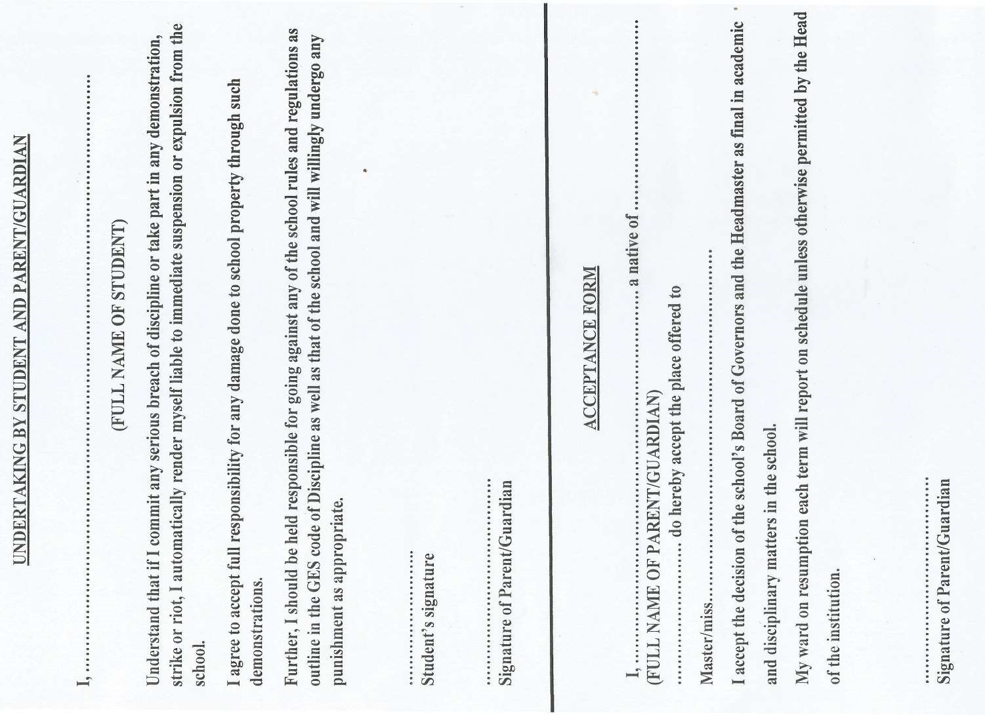
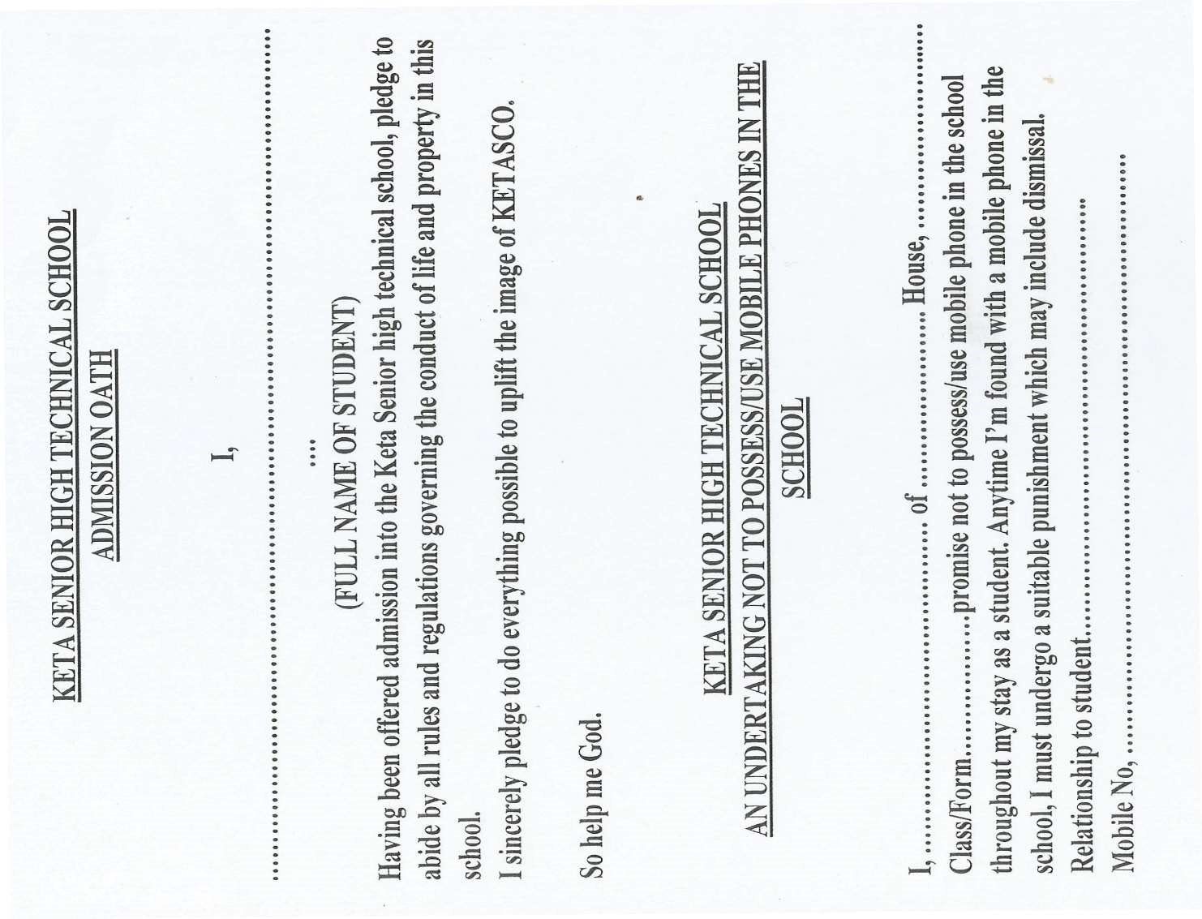
11
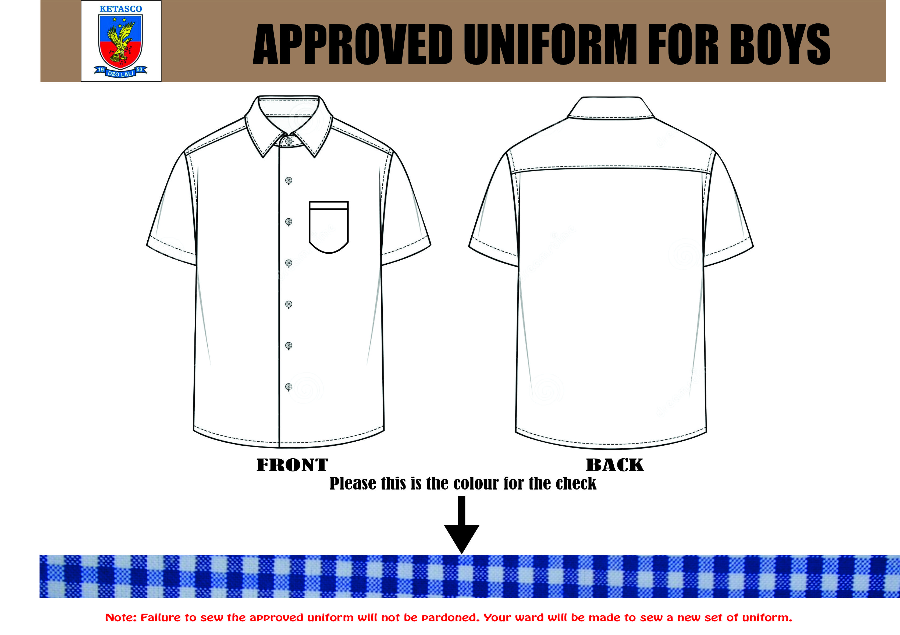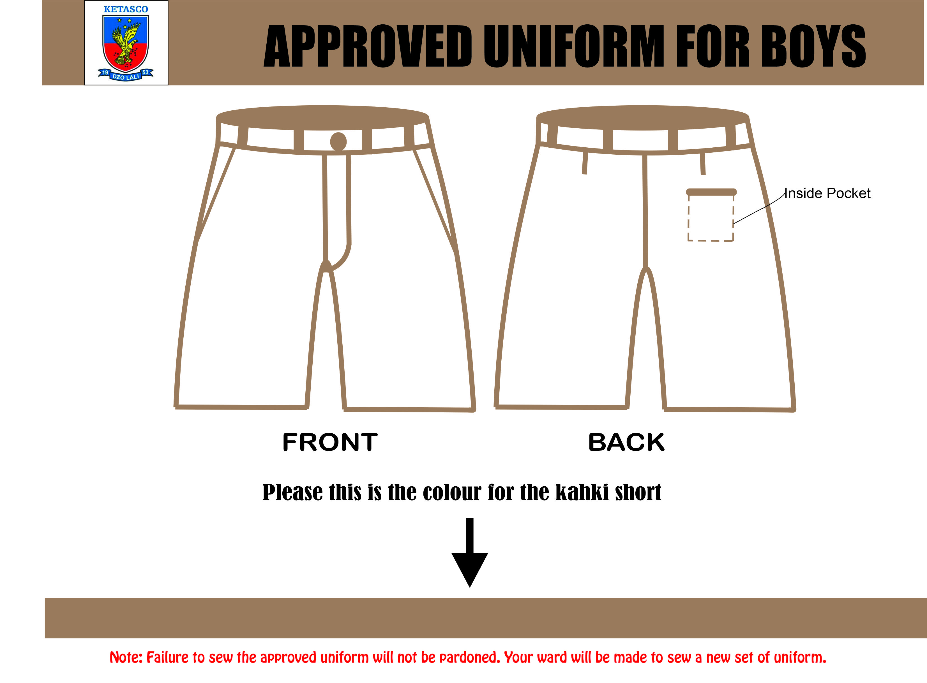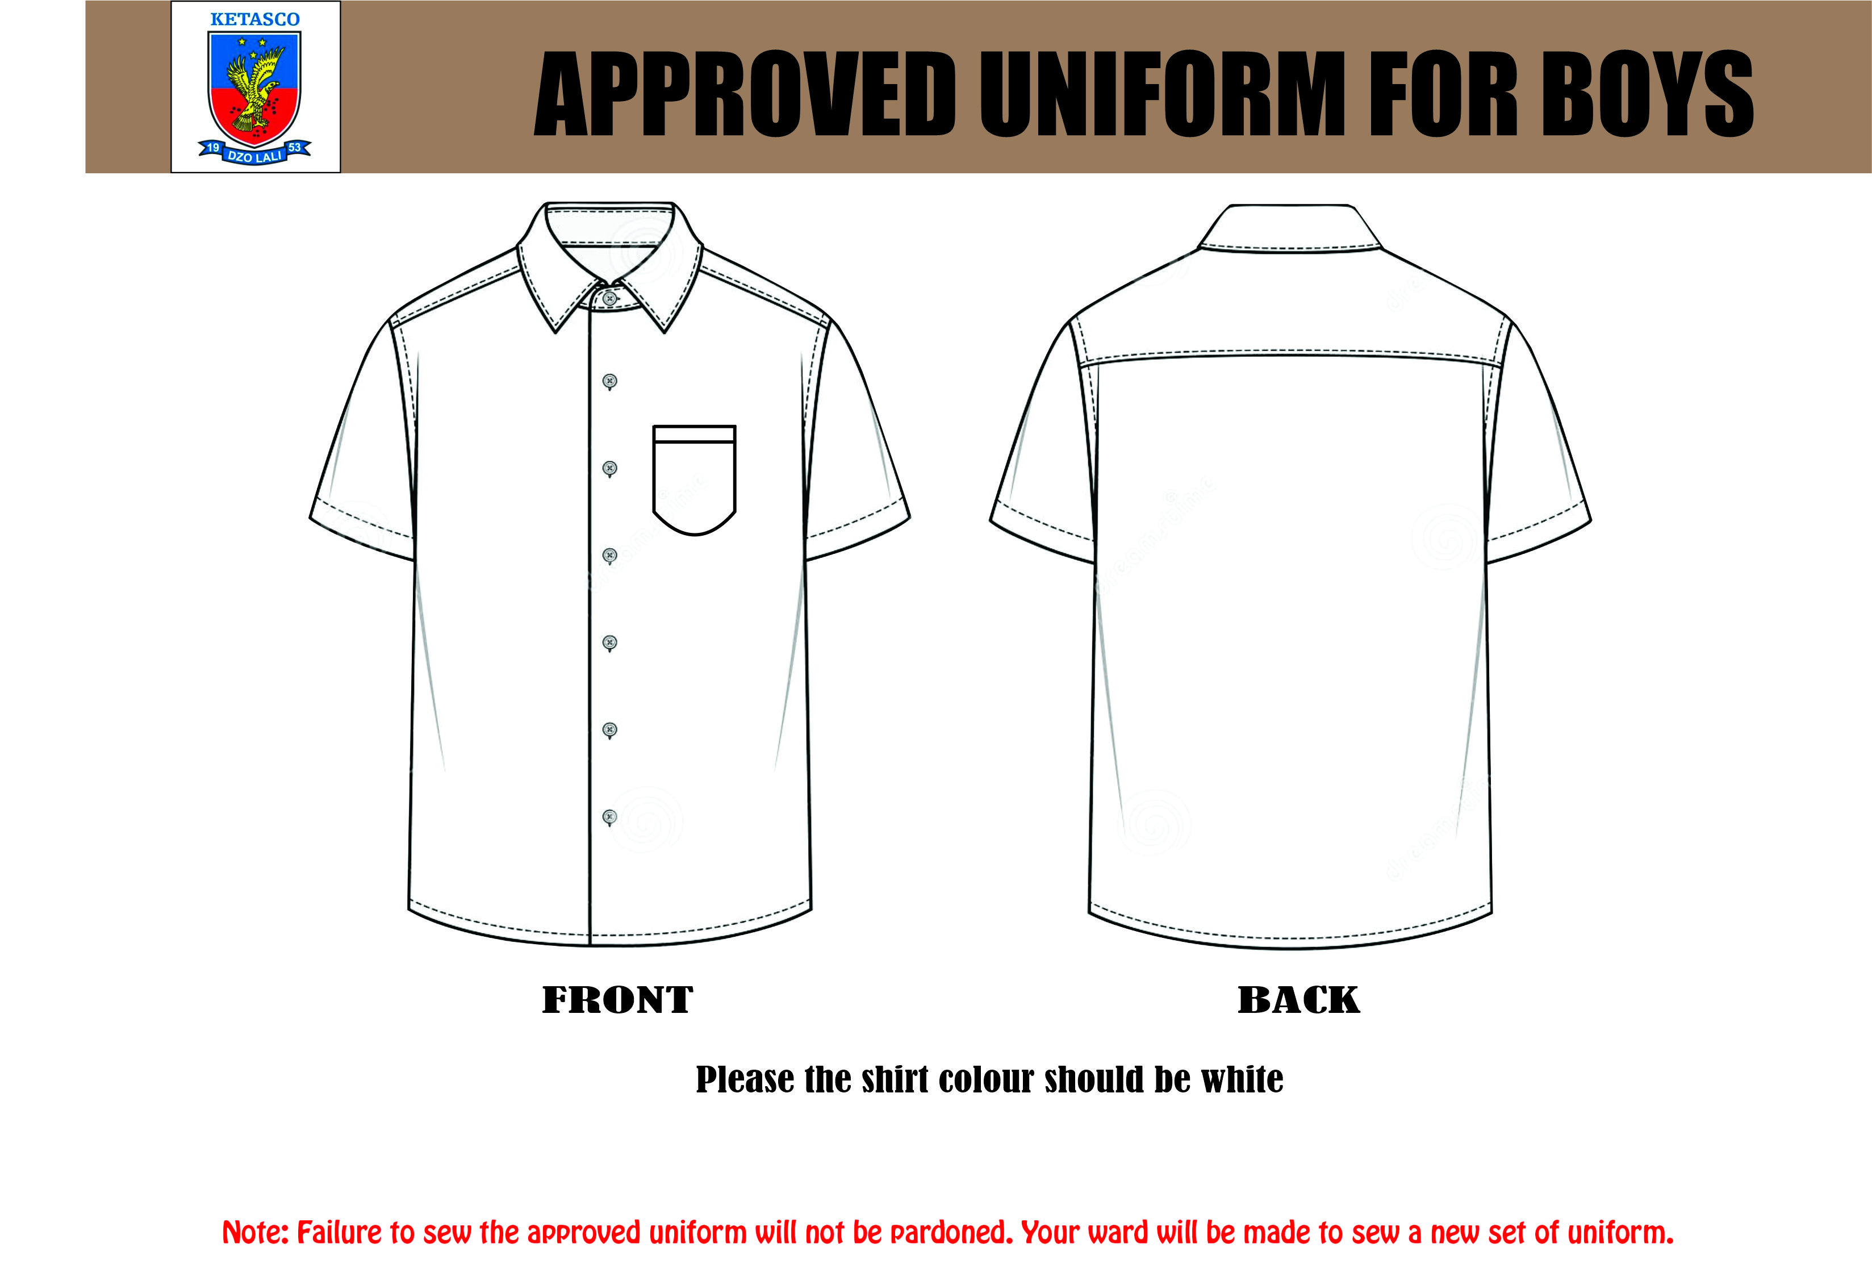

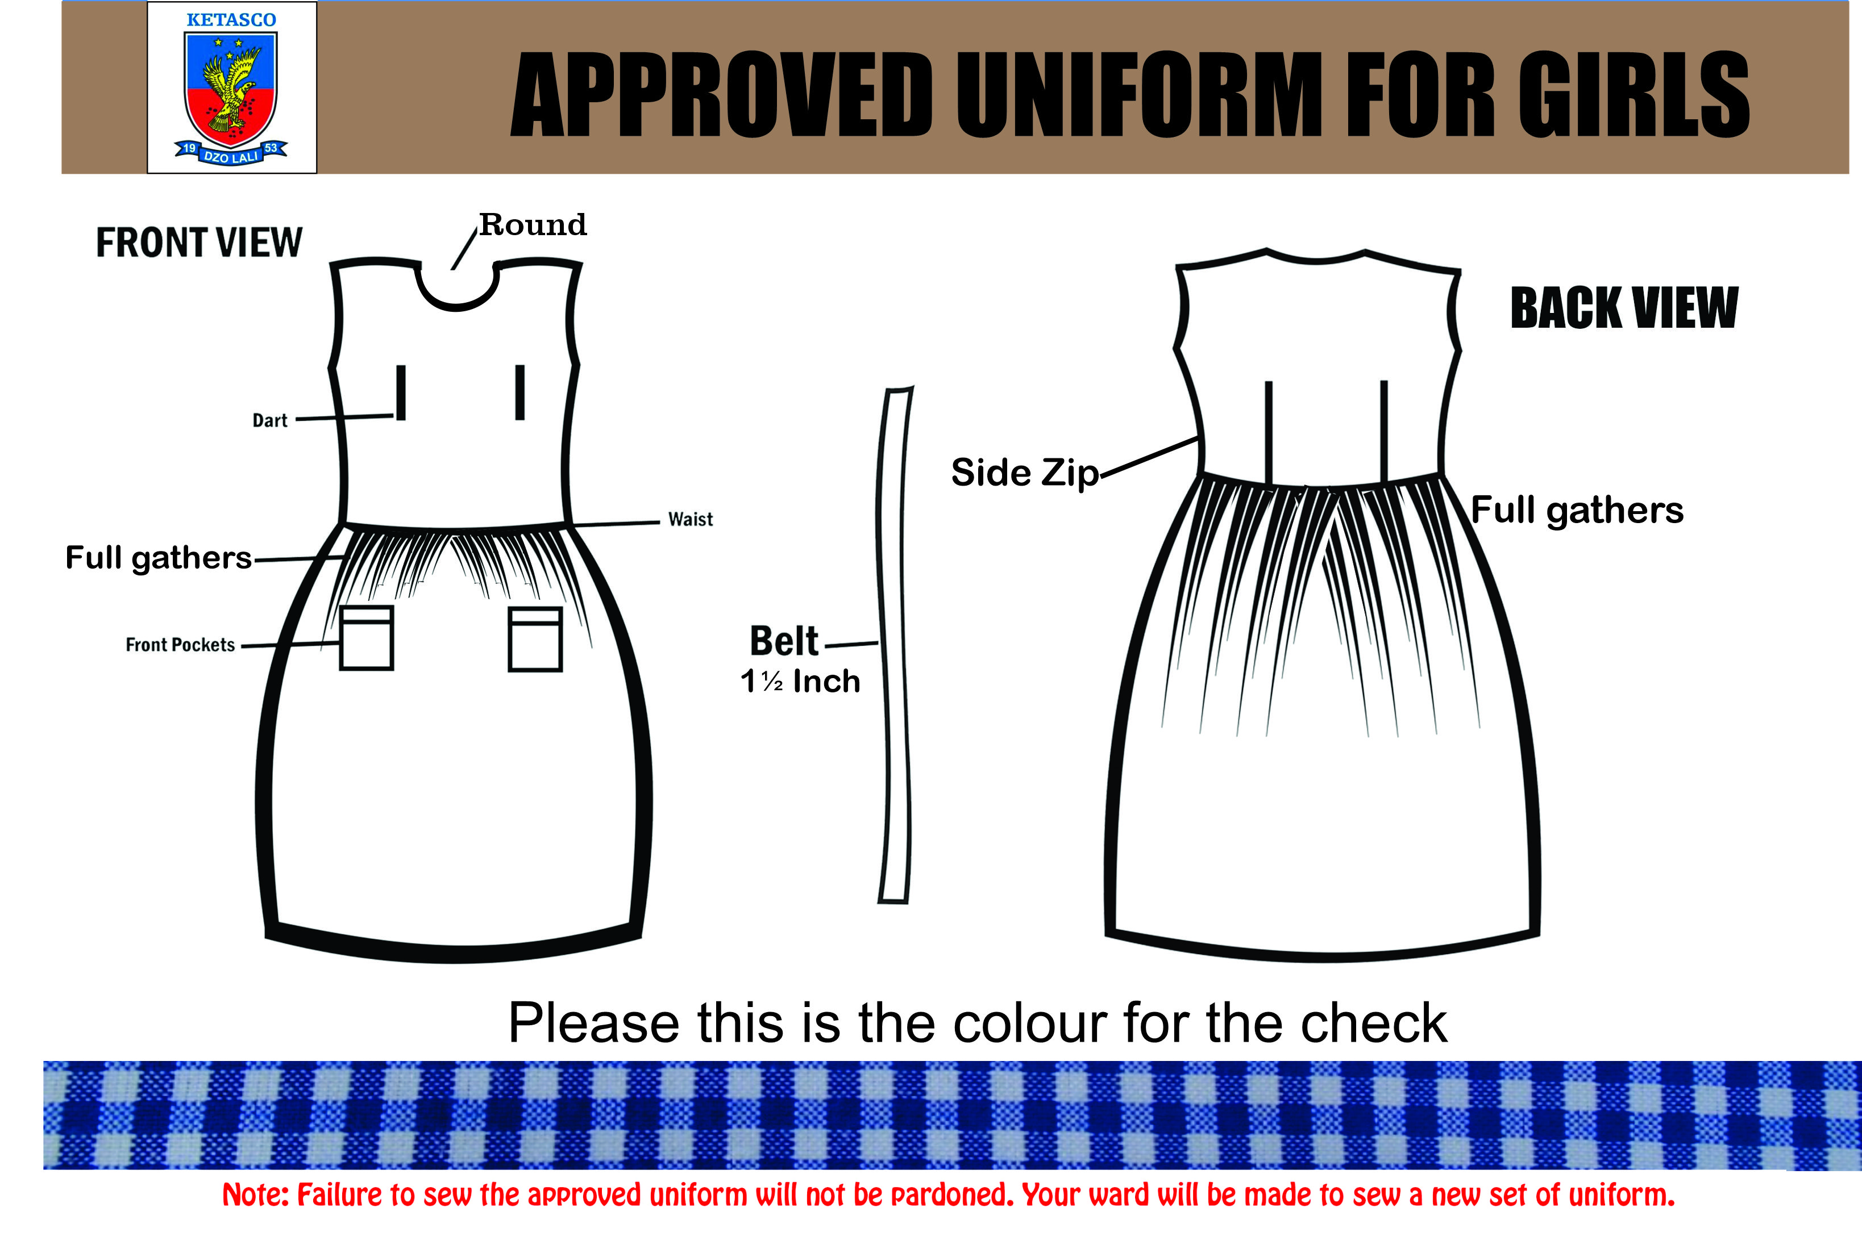

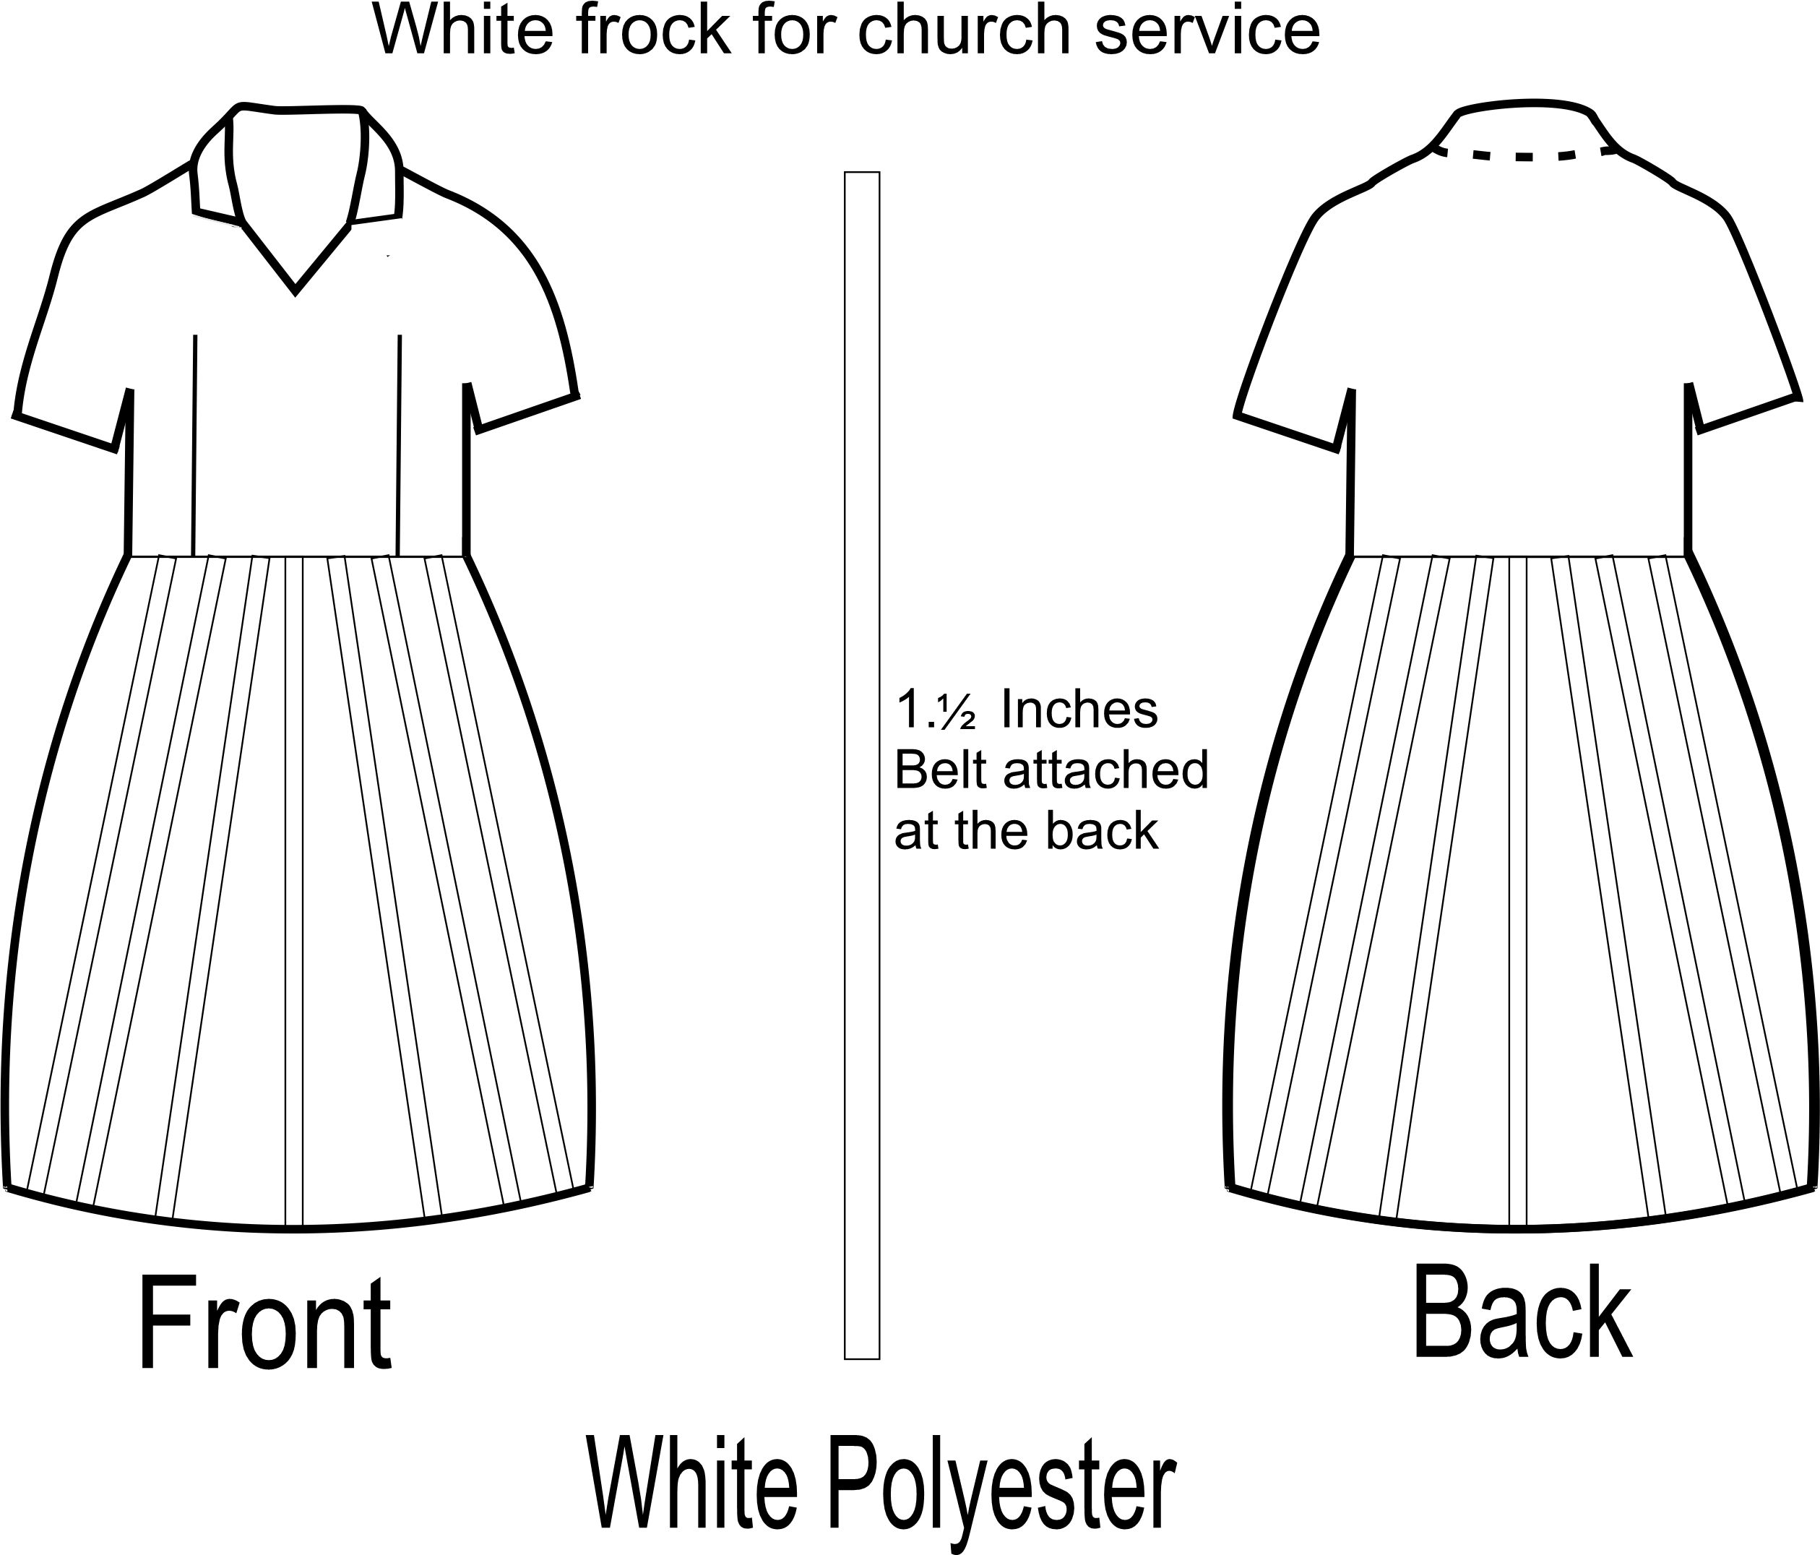

THANK YOU

