KETA SENIOR HIGH TECHNICAL SCHOOL

BANKER’S:
GHANA COMMERCIAL BANK LTD. KETA
P. O. BOX KW 122 KETA, V/R
March 2022
E-mail: info@ketashts.com
TELEPHONE: 0362194864
Our Ref:.GES/VR/KSHTS.91/SF.3/5
Your Ref:........................................

FREE SENIOR HIGH SCHOOL ADMISSION
KETA SENIOR HIGH TECHNICAL SCHOOL
MARCH, 2022 – FORM ONE (1)

I am pleased to inform you that your son/daughter/ward, having passed the 2021 Basic Education Certificate Examination (BECE) has been placed in this school by the Computerized School Selection and Placement System (CSSPS) Secretariat to pursue___________________________________________programme. You are therefore requested to download, fill and submit to the school the admission documents.
If the placement is accepted, he/she is requested to report for school on _________________________2022. Your son/daughter/ward would be admitted as a day/boarding student.

PLEASE NOTE THAT, THIS ADMISSION IS FOR 2022 ONLY AND THEREFORE CANNOT BE USED FOR ADMISSION NEXT ACADEMIC YEAR.
Please complete the additional admission forms attached and return them to the Headmaster when your child/ward reports for school.
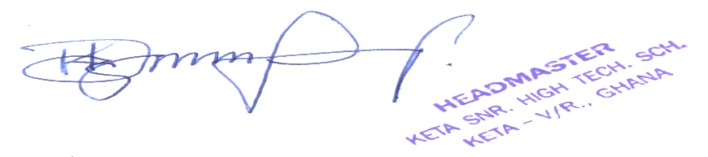
Thank you.

ISAAC KOFI DZIDZIENYO
HEADMASTER

……………………………………………
……………………………………………
……………………………………………
……………………………………………

